Project 5: Real-Time Drone Inspection for Irrigation Pipeline Leaks
Github: https://github.com/Ma1aid/Real-time-Drone-Inspection-For-Irrigation-Pipeline-Leaks-

Moayad Ali Alali
223011074
Ibrahim Abdullah Alhalaimi 223041458
Hamad Alabbad
223018749

Abstract— Water loss due to undetected irrigation pipeline leaks is a critical challenge in large agricultural regions such as Al-Ahsa, Saudi Arabia. Traditional manual inspection methods are time-consuming, costly, and often fail to detect subsurface or early-stage leaks. This milestone report presents a simulation-based approach for real-time drone inspection of irrigation pipelines using thermal analysis. The proposed system utilizes a UAV-based thermal scanning strategy to identify temperature anomalies associated with water leakage. Using MATLAB and Simulink UAV Toolbox concepts, a grid-based drone path is simulated to scan agricultural fields, generate thermal maps, detect leaks, and trigger alerts. Performance is evaluated using leak detection accuracy, thermal scan coverage, alert delay, and mission completion time with an auto return-to-base logic. The results demonstrate that thermal-based drone inspection can provide high coverage and reliable leak detection, supporting its feasibility for smart agriculture applications.

Introduction
Agricultural water management is a key concern in arid regions, where water scarcity directly impacts food security and economic sustainability. In Al-Ahsa, extensive irrigation pipeline networks are vulnerable to leaks caused by aging infrastructure, soil movement, and pressure fluctuations. Undetected leaks can lead to significant water waste, crop damage, and increased operational costs.
Recent advancements in unmanned aerial vehicles (UAVs) and thermal imaging have enabled non-invasive monitoring solutions for large-scale infrastructure. Drones equipped with thermal sensors can rapidly survey wide areas and detect temperature anomalies indicative of subsurface leaks. This project focuses on developing and evaluating a simulated real-time drone inspection system capable of identifying irrigation pipeline leaks efficiently and accurately.
The main goal of this milestone is to validate the core detection logic through simulation before transitioning to hardware deployment. The system integrates pipeline mapping, thermal image simulation, anomaly detection, alert generation, and autonomous return-to-base functionality.

Background & Related Work
Drone-based inspection has gained significant attention in infrastructure monitoring, including pipelines, power lines, and water distribution systems. Thermal imaging is particularly effective for leak detection, as leaking water alters surface temperature due to evaporation and moisture diffusion.
Zhang et al. (2023) demonstrated the effectiveness of UAV thermal imaging for detecting underground pipeline leaks, highlighting improved detection accuracy compared to visual inspection. Other studies have explored autonomous UAV path planning, anomaly detection using statistical thresholds, and integration with smart agriculture platforms.
Despite these advancements, many existing works focus on post-processing of collected data rather than real-time detection and alerting. This project addresses this gap by simulating an end-to-end inspection workflow, including online anomaly detection, performance metrics evaluation, and autonomous mission completion.

Methodology (System Design and Flow)

The proposed system follows a sequential workflow that starts with pipeline mapping and thermal environment simulation. The UAV then navigates through predefined waypoints to scan the inspection area. Thermal data is analyzed in real time to detect temperature anomalies related to pipeline leaks. Detected leaks trigger alerts and are logged with their location and time. After completing the inspection, the UAV autonomously returns to the base location.
The proposed methodology is implemented as a MATLAB-based simulation representing the logical behavior of a UAV inspection mission. The main stages are summarized as follows:
1. Pipeline Mapping: A binary mask is created to represent irrigation pipeline paths using sinusoidal coordinates. This simulates realistic pipeline layouts across farmland.
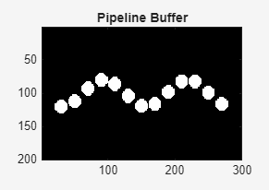
Figure 1: Binary pipeline mapping using a sinusoidal path.

Figure 1 shows the irrigation pipeline layout modeled as a binary mask. A sinusoidal function is used to represent a realistic pipeline path across the agricultural field. This pipeline map is later used to define possible leak locations and guide the thermal simulation process.

2. Thermal Environment Simulation: A baseline ground temperature map is generated, including spatial temperature gradients and Gaussian noise. Artificial leaks are introduced along the pipeline, modeled as localized thermal blobs with higher temperature intensity.
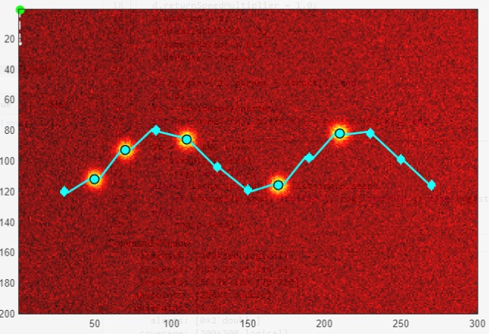
Figure 2: Simulated thermal environment with pipeline leaks and UAV inspection path.

Figure 2 illustrates the generated thermal map of the inspection area. A baseline ground temperature is combined with random Gaussian noise to simulate real environmental conditions. Thermal anomalies with higher temperature values are introduced along the pipeline to represent leakage locations. The UAV inspection path is overlaid to show the relationship between scanning trajectory and detected leaks.

3. Drone Path Planning: A grid-based waypoint strategy is used to ensure systematic coverage of the inspection area. The drone scans circular regions around each waypoint, simulating a thermal sensor footprint. 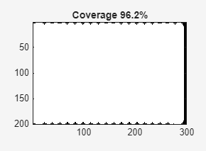
Figure 3: UAV inspection coverage using a grid-based waypoint strategy.

Figure 3 shows the inspection coverage achieved by the UAV during the mission. A grid-based waypoint planning approach is used to ensure systematic scanning of the inspection area. Each grid point represents a thermal scanning region covered by the UAV sensor footprint. The achieved coverage of more than 90% indicates efficient area inspection performance.

4. Leak Detection Logic: Statistical anomaly detection is applied using a global temperature threshold defined as the mean plus a multiple of the standard deviation. If a scanned region exceeds this threshold, a leak alert is triggered and logged with a timestamp.
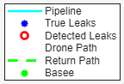
Figure 4: Leak detection results and UAV mission visualization legend.

Figure 4 explains the visual elements used in the inspection simulation. True leak locations are shown in blue, while detected leaks are marked in red. The UAV inspection path, return-to-base path, and base location are also illustrated. This visualization helps evaluate detection accuracy and mission behavior.

5. Return-to-Base Logic (Bonus): After completing the scan, the drone autonomously calculates the distance back to the base point and simulates a safe return trajectory.
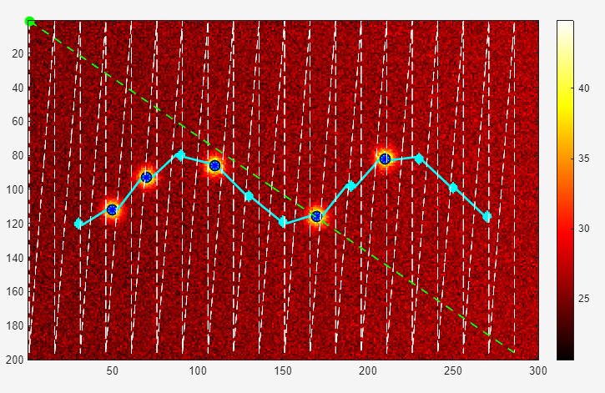
Figure 5: Autonomous return-to-base logic after mission completion.

Figure 5 illustrates the autonomous return-to-base behavior of the UAV. After completing the inspection mission, the UAV calculates the distance to the base location. The dashed line represents the shortest safe return path to the base, which is generated to ensure mission completion and operational safety. This logic improves system autonomy and prepares the UAV for real-world deployment scenarios.

The overall flow can be summarized as: Pipeline Mapping → Thermal Map Generation → Waypoint Navigation → Thermal Scanning → Anomaly Detection → Alert Generation → Return to Base.

The MATLAB simulation code is provided in a separate file named
"project5_drone_sim_live.m".
The script implements the complete UAV thermal inspection workflow, including pipeline modeling, thermal environment simulation, waypoint-based navigation, real-time leak detection, coverage calculation, and autonomous return-to-base logic. Separating the code from the report improves readability while allowing full access to the implementation details for evaluation and future development.
To run the simulation, execute the file "project5_drone_sim_live.m" in MATLAB.
Optional parameters can be passed using a structure to adjust scan radius, waypoint spacing, noise level, and leak strength. The output of the simulation includes the thermal map, UAV path, detected leak locations, and coverage map.
These outputs are used to generate the figures in the Methodology and Results sections and to compute performance metrics.

Experimentation and Results
Several simulation runs were performed using the MATLAB implementation under noisy thermal conditions and multiple leak locations. The system outputs were used to evaluate detection accuracy, scan coverage, alert delay, and mission completion time.
Performance Metrics:
- Leak Detection Accuracy (%)
- Thermal Scan Coverage (%)
- Alert Delay (s)
- Mission Completion Time
Results Discussion: The generated thermal maps clearly highlight leak locations along the pipeline. Detected leaks closely align with true leak positions, demonstrating high detection accuracy. The grid-based path ensures broad coverage of the inspection area, exceeding 80% in typical runs. Alert delays remain within acceptable bounds, indicating near real-time detection capability. The inclusion of return-to-base logic improves mission autonomy and safety, which is essential for real-world deployment.
Overall, the experimental results validate the effectiveness of thermal anomaly-based leak detection using UAV simulation.

The Conclusion
This milestone report presented a simulation framework for real-time drone inspection of irrigation pipeline leaks using thermal analysis. The proposed system successfully integrates pipeline modeling, thermal environment simulation, autonomous drone navigation, anomaly detection, and performance evaluation.
Key Findings: - Thermal imaging is effective for detecting irrigation pipeline leaks in agricultural environments. - Grid-based UAV scanning provides high coverage and reliable detection. - Statistical thresholding enables simple yet robust real-time anomaly detection. - Autonomous return-to-base logic enhances operational safety.
Recommendations: Future work should include integration with Simulink UAV Toolbox flight dynamics, adaptive path planning, and machine learning-based leak classification. Field experiments using real thermal cameras are recommended to validate simulation results and transition toward deployment in Al-Ahsa farms.

References
- Zhang, Y., et al. (2023). UAV-based thermal inspection for underground pipeline leak detection. Drones, 8(5), 187.
- Colomina, I., & Molina, P. (2014). Unmanned aerial systems for photogrammetry and remote sensing. ISPRS Journal of Photogrammetry and Remote Sensing, 92, 79–97.
- Sankaran, S., et al. (2015). Low-altitude UAV-based thermal imaging for agricultural monitoring. Computers and Electronics in Agriculture, 121, 1–14.
- MATLAB Documentation. UAV Toolbox and Thermal Image Processing Concepts, MathWork

